**blockquot va listdan foydalanib list.html fayli quidagi shaklda yasalsin:**

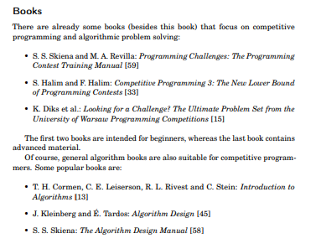

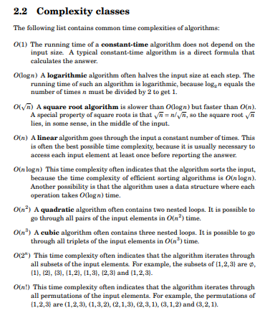

**Ildizni _/n deb ketaverasizlar**

**Quidagi kitob mundarijasining “mundarija.html” html hujjati yaratilsin:**

**(<dl> <dt> <dd> lardan ham foydalanishingiz mumkin)**

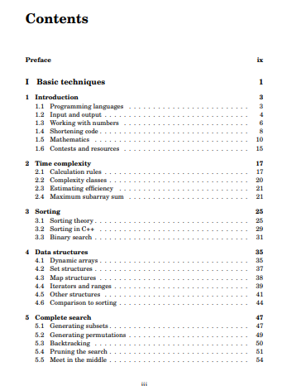

**Quidagi jadval olimpiada.html faylida yaratilsin (Chiziqlari shart emas)**

**Ikkita katakni bitta qilish uchun <td colspan=”2”>….</td> kabi atribut ishlatiladi.**

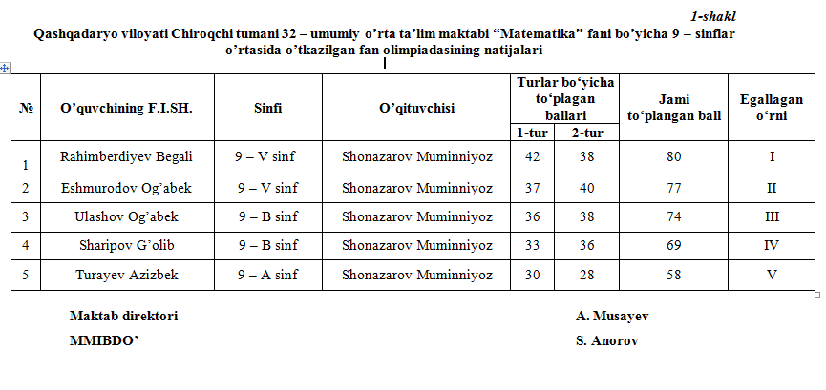

**xodimlar.html fayli yaratilsin**

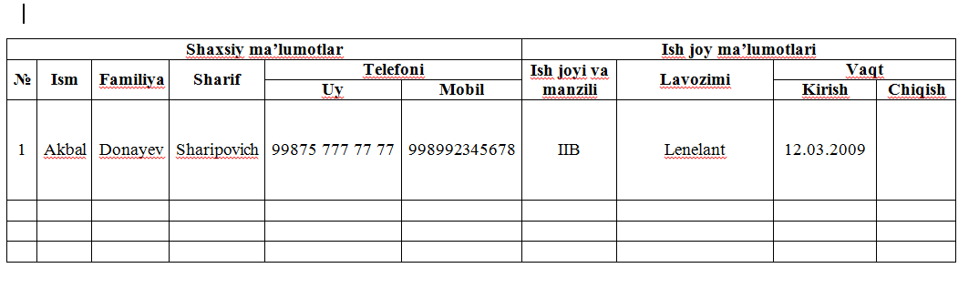

|  |  |  |  |  |  |  |  |  |  |
| --- | --- | --- | --- | --- | --- | --- | --- | --- | --- |
| **Shaxsiy ma’lumotlar** | | | | | | **Ish joy ma’lumotlari** | | | |
| **№** | **Ism** | **Familiya** | **Sharif** | **Telefoni** | | **Ish joyi va manzili** | **Lavozimi** | **Vaqt** | |
| **Uy** | **Mobil** | **Kirish** | **Chiqish** |
| 1 | Akbal | Donayev | Sharipovich | 99875 777 77 77 | 998992345678 | IIB | Lenelant | 12.03.2009 |  |
|  |  |  |  |  |  |  |  |  |  |
|  |  |  |  |  |  |  |  |  |  |
|  |  |  |  |  |  |  |  |  |  |

**Quyidagi shakl yasalsin:**

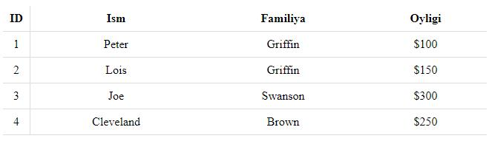

**Quidagi shakl yasalsin**

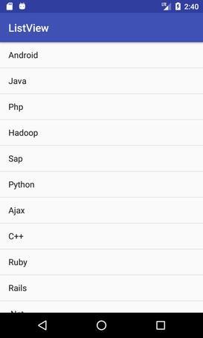

**Quidagi shakl yasalsin:**

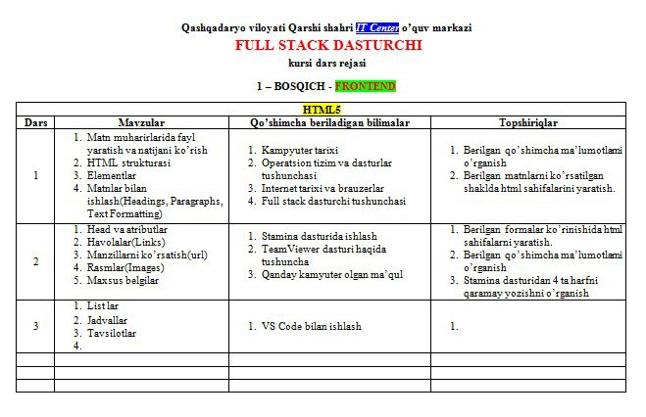

**Quidagi shakl yasalsin**

